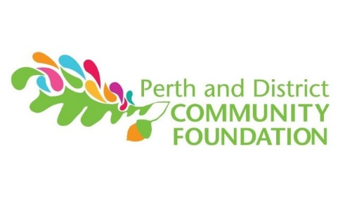
Community Grant Report Form

ORGANIZATION Name: | Charitable Registration #:
On or before October 30 of the year a grant is received, grant recipients must submit a final report describing the use of the grant. If the project can only be completed by December 31st, an interim report must be submitted by October 30, with the final report due upon completion of the project.
Submission of the report to PDCF is a prerequisite to be considered for future funding.
- 1. What were the specific and measurable goals for your project/activity, as set out in your application? How and to what extent were they achieved?

- 2. Describe how your project/activity has or will benefit people in this community, including information on how many people you reached through the project/activity?

- 3. Please indicate, in the form of an attached financial statement, how the funds were spent.
- 4. Was additional funding leveraged from other sources as a result of the Foundation's grant? If so, please indicate the extent in terms of financial help, help in-kind, partnerships (e.g., municipalities, corporations, other sponsors, etc.) and increase in number of volunteers.

- 5. Please indicate if you were able to highlight the Foundation's contribution in the media and/or through alternative measures.

- 6. Other comments / observations:

Recognition request: When referring to your program in the media please make mention of the fact that the project received support from The Perth and District Community Foundation. Also please use, where possible, the Foundation's logo on written information and signage. The logo at the top of this form is available electronically by contacting us at 613-326-0295; by email at info@pdcf.ca or on the website www.pdcf.ca under 'Grants'. The Grant Reporting Form should be returned to The Perth and District Community Foundation at 33 Lewis St, Perth ON, K7H 2R4 by October 30 in the year the grant is received.

